Zero-Emission Heavy-Lift Forklifts
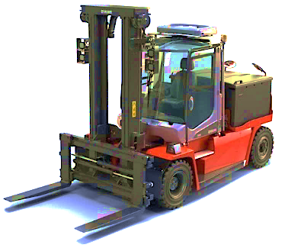 | Funding Available Statewide  Up to 75% - 100% of Eligible Costs per Forklift
Applications accepted on first-come, first-served basis

Scrap and replace internal combustion forklifts with all-electric equipment

- Eligible equipment includes forklifts with a lift capacity of 8,001 lbs or greater.
- Forklift can operate in any sector anywhere in California.
- May be any type of combustion-fueled baseline equipment, including diesel Tier 4 or earlier.
- New equipment must be placed into service within 18 months from date of Notice to Proceed.
- Baseline equipment must be in compliance with applicable CARB fleet rules at the time of application.
- Stacking with other State incentive funds that do not claim NOx emission reductions (e.g., CORE) is allowed.

You will need the following documentation to apply:
About your Organization:  - General and property liability insurance;  - Compliance demonstration with CARB regulations for equipment and for applicant’s fleet; and  - Applicant W-9 | About your Equipment:  - Photos of existing equipment with engine tag(s);  - CARB Executive Order(s) for existing engine(s);  - Itemized quotes for new zero-emission equipment and any included infrastructure.
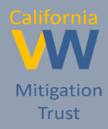
Please refer to the Solicitation Guidance for full details
For more information, please use these resources:
   | https://www.californiavwtrust.org/zero-freight-marine/ | 
 | CaliforniaVWTrust@baaqmd.gov
 | 1-844-9VW-FUND

