Zero-Emission Port Cargo Handling Equipment (CHE)
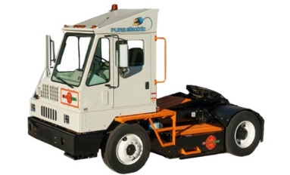 | Funding Available Statewide  Up to 75% - 100% of Eligible Costs per Equipment
Applications accepted on first-come, first-served basis

Scrap and replace internal combustion CHE with all-electric equipment:
- Eligible equipment includes rubber-tired gantry cranes, straddle carriers, shuttle carriers, terminal tractors, yard hostlers, yard tractors, yard trucks, and more.
- Must operate in a ‘port’, including seaports, railyards, freight terminals, intermodal facilities, etc.
- May be any type of combustion-fueled baseline equipment, including diesel Tier 4 or earlier.
- New equipment must be installed and operational within 18 months from date of Notice to Proceed.
- Baseline equipment must be in compliance with applicable CARB fleet rules at the time of application.
- Stacking with other State incentive funds that do not claim NOx emission reductions (e.g., CORE) is allowed.

You will need the following documentation to apply:

About your Organization:  - General and property liability insurance;  - Compliance demonstration with CARB regulations for equipment and fleet; and  - Applicant W-9 | About your Equipment:  - Photos of existing equipment with engine tag(s);  - CARB Executive Order(s) for existing engine(s); and  - Itemized quotes for new zero-emission equipment and infrastructure.
Please refer to the Solicitation Guidance for full details
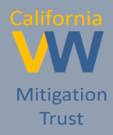
For more information, please use these resources:
   | https://www.californiavwtrust.org/zero-freight-marine/ | 
 | CaliforniaVWTrust@baaqmd.gov
 | 1-844-9VW-FUND

